# ------------------------------------ rf_10_34 ------------------------------------

Pre-predictions:

timestamp percentage_current rainfall_current

0 2023-03-06 07:30:00 0.0 0.0

1 2023-03-06 07:35:00 0.0 0.0

2 2023-03-06 07:40:00 0.0 0.0

3 2023-03-06 07:45:00 0.0 0.0

4 2023-03-06 07:50:00 0.0 0.0

5 2023-03-06 07:55:00 0.0 0.0

Metrics for this specific prediction:

Accuracy: 99.99%

Mean squared error: 0.10353267366431446

Variance (R²) score: 1.00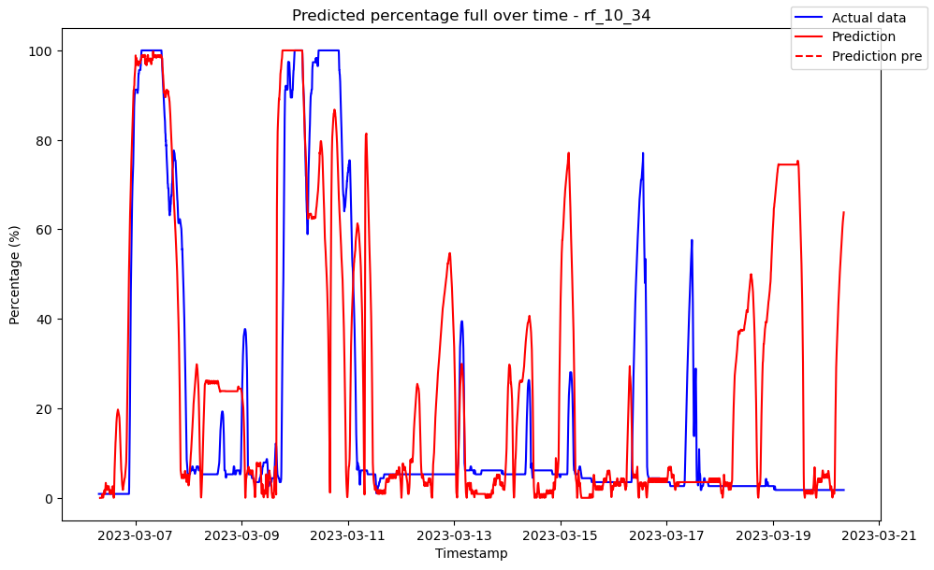

# ------------------------------------ rf_2_33 ------------------------------------

Pre-predictions:

timestamp percentage_current rainfall_current

0 2023-03-06 07:30:00 0.0 0.0

1 2023-03-06 07:35:00 0.0 0.0

2 2023-03-06 07:40:00 0.0 0.0

3 2023-03-06 07:45:00 0.0 0.0

4 2023-03-06 07:50:00 0.0 0.0

5 2023-03-06 07:55:00 0.0 0.0

Metrics for this specific prediction:

Accuracy: 99.99%

Mean squared error: 0.10432617652735668

Variance (R²) score: 1.00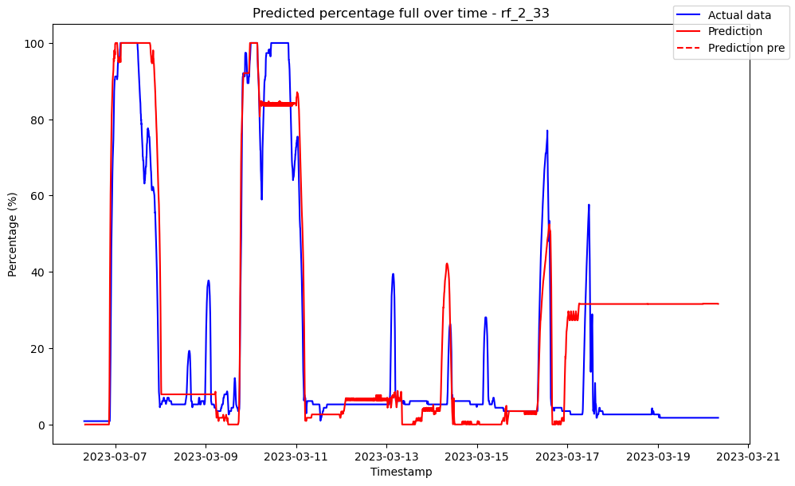

# ------------------------------------ rf_2_37 ------------------------------------

Pre-predictions:

timestamp percentage_current rainfall_current

0 2023-03-06 07:30:00 0.0 0.0

1 2023-03-06 07:35:00 0.0 0.0

2 2023-03-06 07:40:00 0.0 0.0

3 2023-03-06 07:45:00 0.0 0.0

4 2023-03-06 07:50:00 0.0 0.0

5 2023-03-06 07:55:00 0.0 0.0

Metrics for this specific prediction:

Accuracy: 99.99%

Mean squared error: 0.1009228960734122

Variance (R²) score: 1.00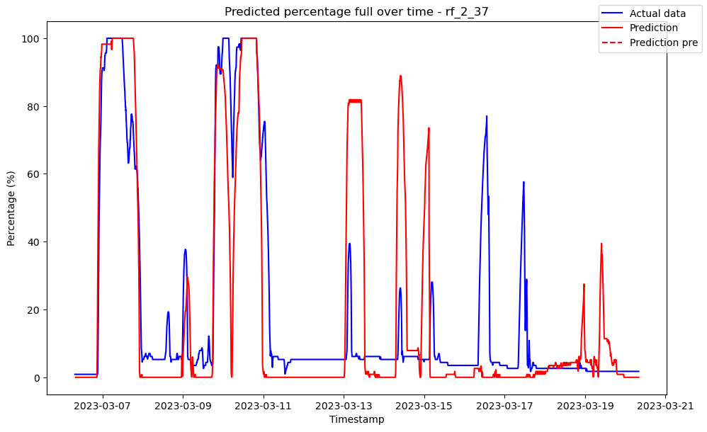

# ------------------------------------ rf_2_43 ------------------------------------

Pre-predictions:

timestamp percentage_current rainfall_current

0 2023-03-06 07:30:00 0.0 0.0

1 2023-03-06 07:35:00 0.0 0.0

2 2023-03-06 07:40:00 0.0 0.0

3 2023-03-06 07:45:00 0.0 0.0

4 2023-03-06 07:50:00 0.0 0.0

5 2023-03-06 07:55:00 0.0 0.0

Metrics for this specific prediction:

Accuracy: 99.99%

Mean squared error: 0.0985892669274751

Variance (R²) score: 1.00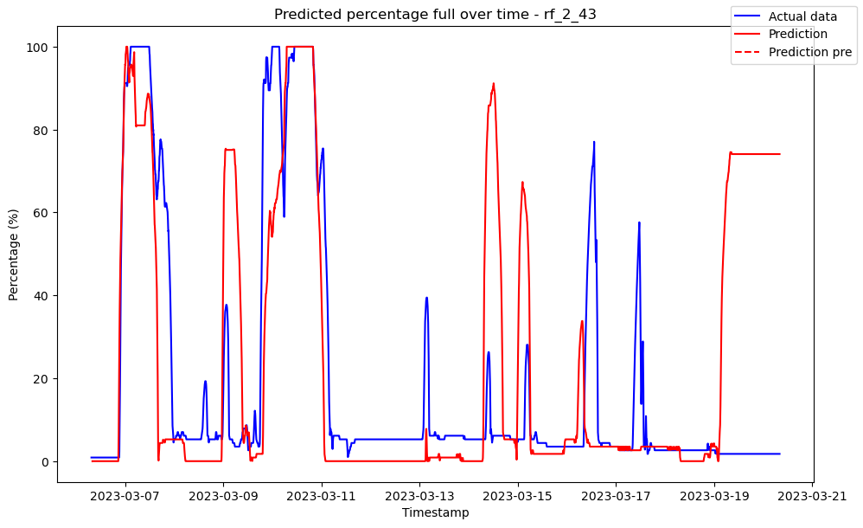

# ------------------------------------ rf_3_23 ------------------------------------

Pre-predictions:

timestamp percentage_current rainfall_current

0 2023-03-06 07:30:00 0.0 0.0

1 2023-03-06 07:35:00 0.0 0.0

2 2023-03-06 07:40:00 0.0 0.0

3 2023-03-06 07:45:00 0.0 0.0

4 2023-03-06 07:50:00 0.0 0.0

5 2023-03-06 07:55:00 0.0 0.0

Metrics for this specific prediction:

Accuracy: 99.99%

Mean squared error: 0.13590735261825004

Variance (R²) score: 1.00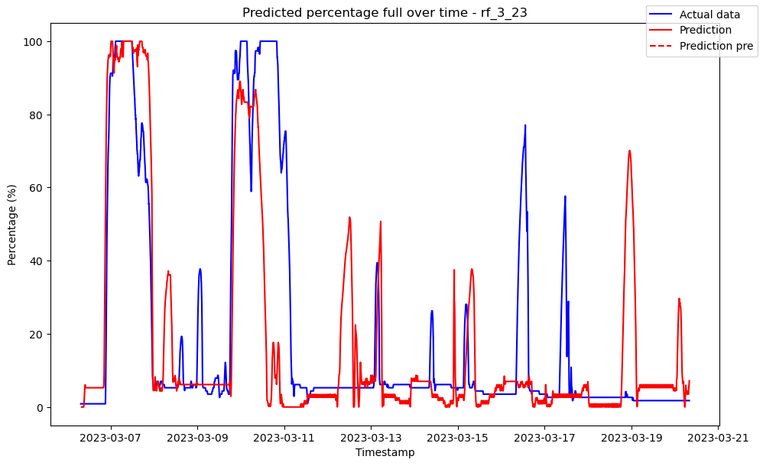

# ------------------------------------ rf_3_30 ------------------------------------

Pre-predictions:

timestamp percentage_current rainfall_current

0 2023-03-06 07:30:00 0.0 0.0

1 2023-03-06 07:35:00 0.0 0.0

2 2023-03-06 07:40:00 0.0 0.0

3 2023-03-06 07:45:00 0.0 0.0

4 2023-03-06 07:50:00 0.0 0.0

5 2023-03-06 07:55:00 0.0 0.0

Metrics for this specific prediction:

Accuracy: 99.99%

Mean squared error: 0.14744669152020304

Variance (R²) score: 1.00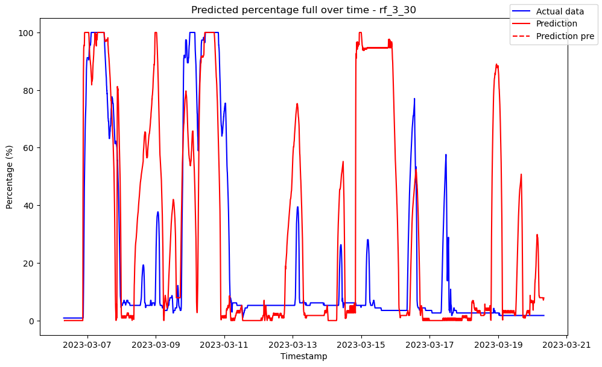

# ------------------------------------ rf_3_31 ------------------------------------

Pre-predictions:

timestamp percentage_current rainfall_current

0 2023-03-06 07:30:00 0.0 0.0

1 2023-03-06 07:35:00 0.0 0.0

2 2023-03-06 07:40:00 0.0 0.0

3 2023-03-06 07:45:00 0.0 0.0

4 2023-03-06 07:50:00 0.0 0.0

5 2023-03-06 07:55:00 0.0 0.0

Metrics for this specific prediction:

Accuracy: 99.99%

Mean squared error: 0.11723516305718812

Variance (R²) score: 1.00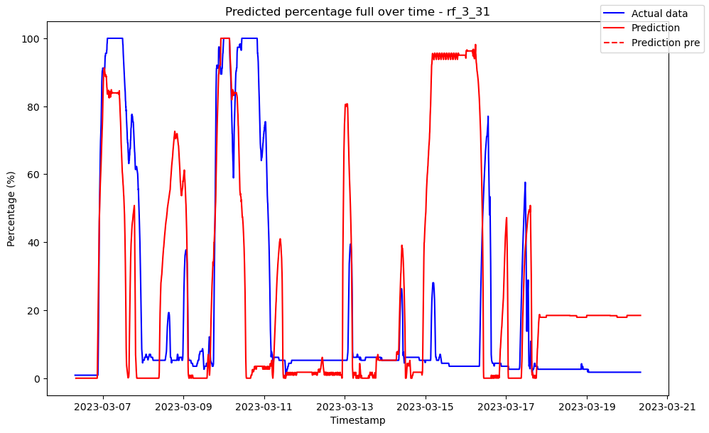

# ------------------------------------ rf_3_32 ------------------------------------

Pre-predictions:

timestamp percentage_current rainfall_current

0 2023-03-06 07:30:00 0.0 0.0

1 2023-03-06 07:35:00 0.0 0.0

2 2023-03-06 07:40:00 0.0 0.0

3 2023-03-06 07:45:00 0.0 0.0

4 2023-03-06 07:50:00 0.0 0.0

5 2023-03-06 07:55:00 0.0 0.0

Metrics for this specific prediction:

Accuracy: 99.99%

Mean squared error: 0.10150336418202043

Variance (R²) score: 1.00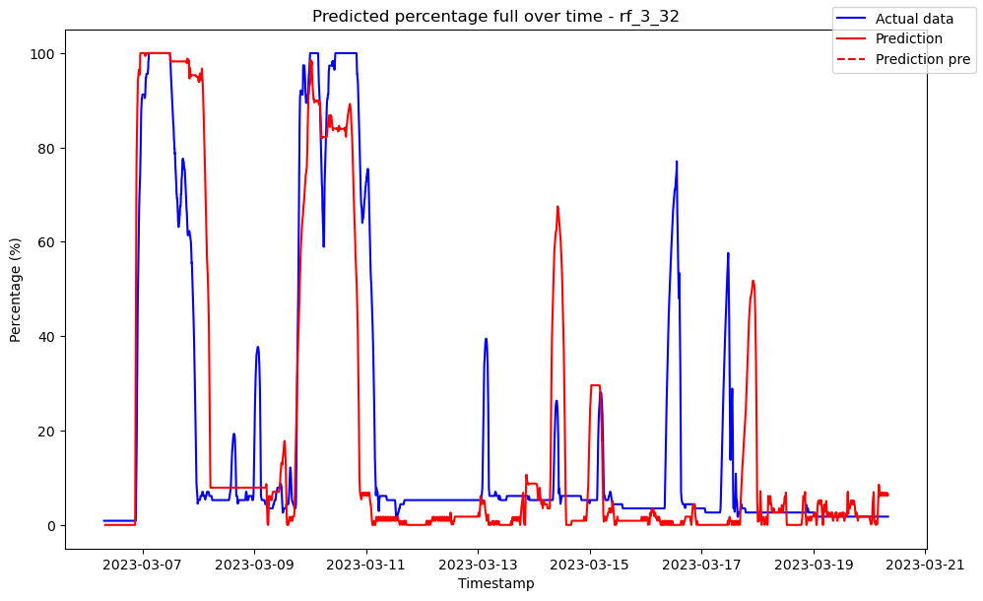

# ------------------------------------ rf_3_35 ------------------------------------

Pre-predictions:

timestamp percentage_current rainfall_current

0 2023-03-06 07:30:00 0.0 0.0

1 2023-03-06 07:35:00 0.0 0.0

2 2023-03-06 07:40:00 0.0 0.0

3 2023-03-06 07:45:00 0.0 0.0

4 2023-03-06 07:50:00 0.0 0.0

5 2023-03-06 07:55:00 0.0 0.0

Metrics for this specific prediction:

Accuracy: 99.99%

Mean squared error: 0.14465644034987063

Variance (R²) score: 1.00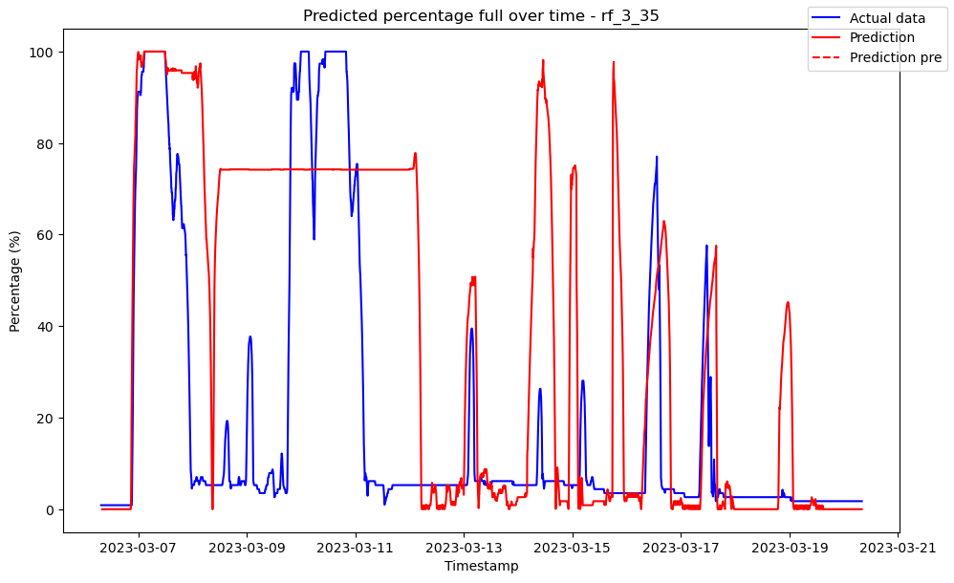

# ------------------------------------ rf_3_36 ------------------------------------

Pre-predictions:

timestamp percentage_current rainfall_current

0 2023-03-06 07:30:00 0.0 0.0

1 2023-03-06 07:35:00 0.0 0.0

2 2023-03-06 07:40:00 0.0 0.0

3 2023-03-06 07:45:00 0.0 0.0

4 2023-03-06 07:50:00 0.0 0.0

5 2023-03-06 07:55:00 0.0 0.0

Metrics for this specific prediction:

Accuracy: 99.99%

Mean squared error: 0.15153284231433545

Variance (R²) score: 1.00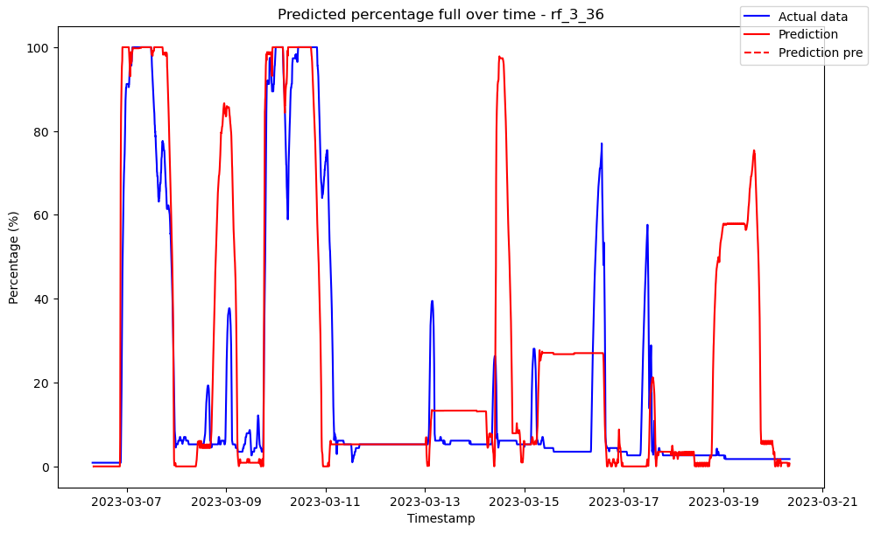

# ------------------------------------ rf_3_43 ------------------------------------

Pre-predictions:

timestamp percentage_current rainfall_current

0 2023-03-06 07:30:00 0.0 0.0

1 2023-03-06 07:35:00 0.0 0.0

2 2023-03-06 07:40:00 0.0 0.0

3 2023-03-06 07:45:00 0.0 0.0

4 2023-03-06 07:50:00 0.0 0.0

5 2023-03-06 07:55:00 0.0 0.0

Metrics for this specific prediction:

Accuracy: 99.99%

Mean squared error: 0.146636343019041

Variance (R²) score: 1.00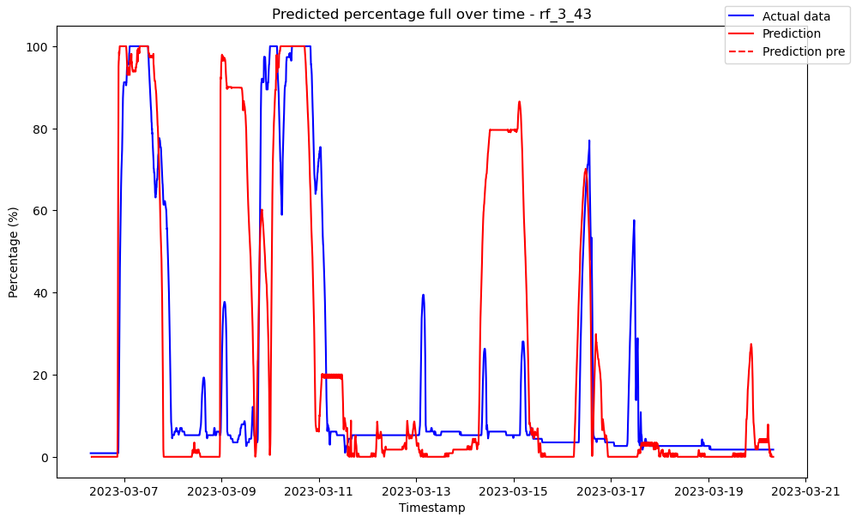

# ------------------------------------ rf_4_22 ------------------------------------

Pre-predictions:

timestamp percentage_current rainfall_current

0 2023-03-06 07:30:00 0.010338 0.0

1 2023-03-06 07:35:00 0.085481 0.0

2 2023-03-06 07:40:00 0.429000 0.0

3 2023-03-06 07:45:00 0.719865 0.0

4 2023-03-06 07:50:00 0.853477 0.0

5 2023-03-06 07:55:00 0.755500 0.0

Metrics for this specific prediction:

Accuracy: 99.99%

Mean squared error: 0.08421579568384206

Variance (R²) score: 1.00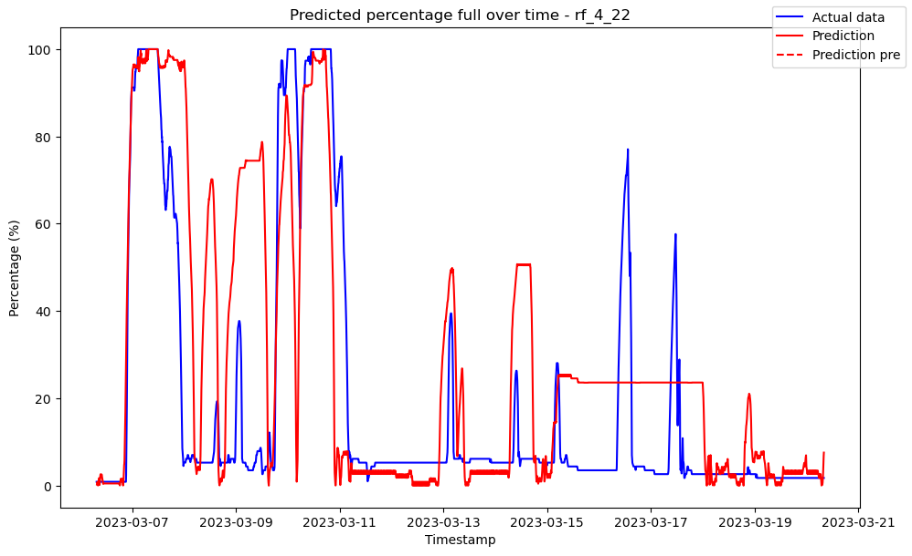

# ------------------------------------ rf_4_27 ------------------------------------

Pre-predictions:

timestamp percentage_current rainfall_current

0 2023-03-06 07:30:00 0.0 0.0

1 2023-03-06 07:35:00 0.0 0.0

2 2023-03-06 07:40:00 0.0 0.0

3 2023-03-06 07:45:00 0.0 0.0

4 2023-03-06 07:50:00 0.0 0.0

5 2023-03-06 07:55:00 0.0 0.0

Metrics for this specific prediction:

Accuracy: 99.99%

Mean squared error: 0.0906572138923795

Variance (R²) score: 1.00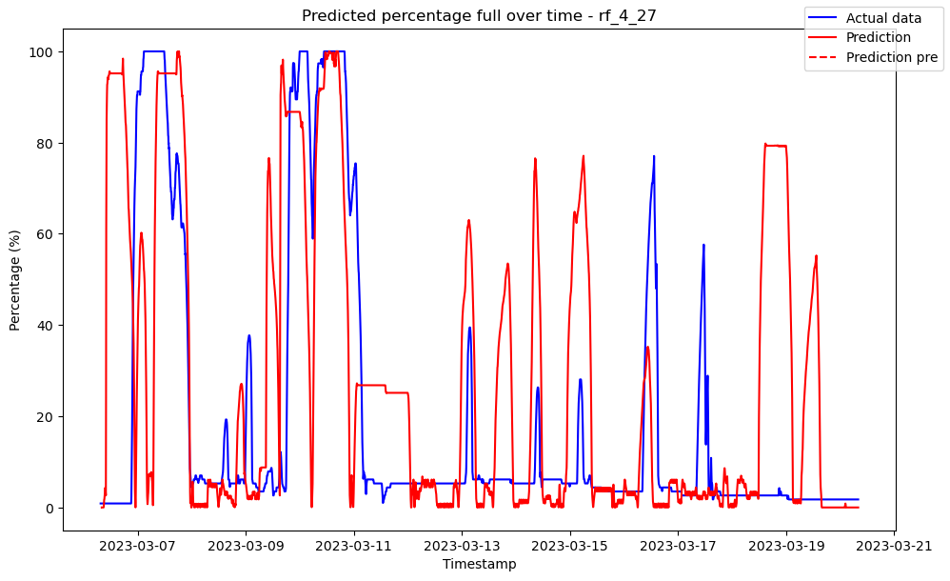

# ------------------------------------ rf_4_45 ------------------------------------

Pre-predictions:

timestamp percentage_current rainfall_current

0 2023-03-06 07:30:00 0.0 0.0

1 2023-03-06 07:35:00 0.0 0.0

2 2023-03-06 07:40:00 0.0 0.0

3 2023-03-06 07:45:00 0.0 0.0

4 2023-03-06 07:50:00 0.0 0.0

5 2023-03-06 07:55:00 0.0 0.0

Metrics for this specific prediction:

Accuracy: 99.99%

Mean squared error: 0.09887783991235671

Variance (R²) score: 1.00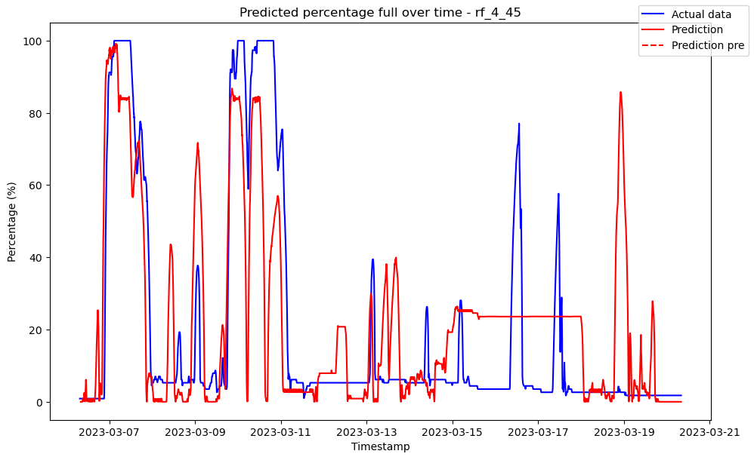

# ------------------------------------ rf_5_22 ------------------------------------

Pre-predictions:

timestamp percentage_current rainfall_current

0 2023-03-06 07:30:00 0.008302 0.0

1 2023-03-06 07:35:00 0.128385 0.0

2 2023-03-06 07:40:00 0.495725 0.0

3 2023-03-06 07:45:00 0.907000 0.0

4 2023-03-06 07:50:00 2.254788 0.0

5 2023-03-06 07:55:00 4.012200 0.0

Metrics for this specific prediction:

Accuracy: 99.99%

Mean squared error: 0.07597503805752043

Variance (R²) score: 1.00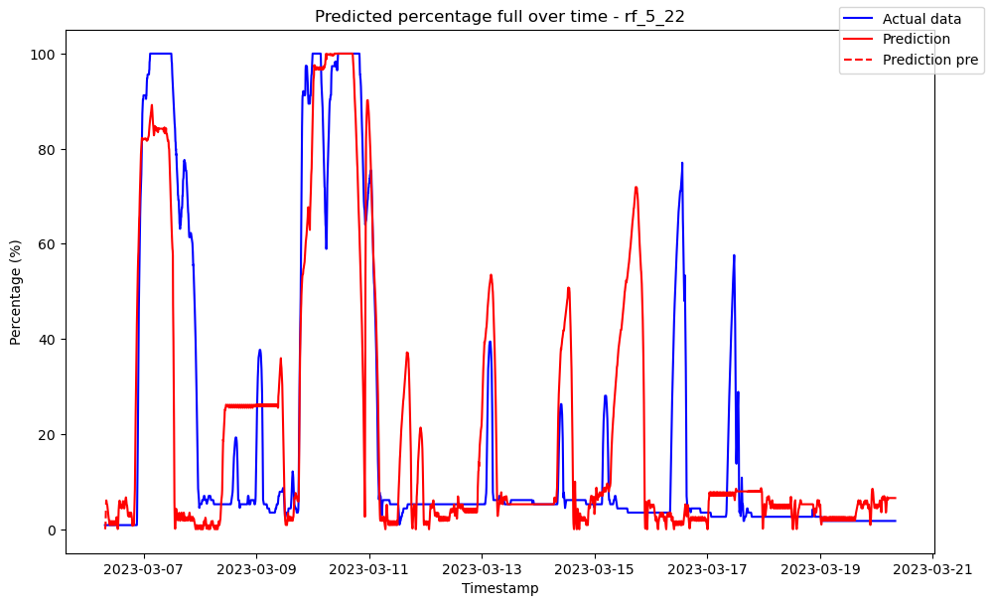

# ------------------------------------ rf_5_29 ------------------------------------

Pre-predictions:

timestamp percentage_current rainfall_current

0 2023-03-06 07:30:00 0.0 0.0

1 2023-03-06 07:35:00 0.0 0.0

2 2023-03-06 07:40:00 0.0 0.0

3 2023-03-06 07:45:00 0.0 0.0

4 2023-03-06 07:50:00 0.0 0.0

5 2023-03-06 07:55:00 0.0 0.0

Metrics for this specific prediction:

Accuracy: 99.99%

Mean squared error: 0.09512081880595614

Variance (R²) score: 1.00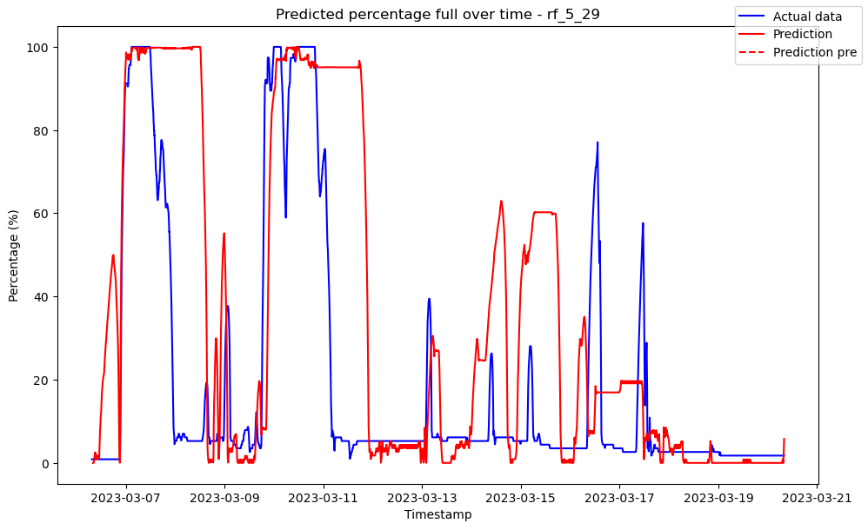

# ------------------------------------ rf_5_35 ------------------------------------

Pre-predictions:

timestamp percentage_current rainfall_current

0 2023-03-06 07:30:00 0.0 0.0

1 2023-03-06 07:35:00 0.0 0.0

2 2023-03-06 07:40:00 0.0 0.0

3 2023-03-06 07:45:00 0.0 0.0

4 2023-03-06 07:50:00 0.0 0.0

5 2023-03-06 07:55:00 0.0 0.0

Metrics for this specific prediction:

Accuracy: 99.99%

Mean squared error: 0.09697191124903876

Variance (R²) score: 1.00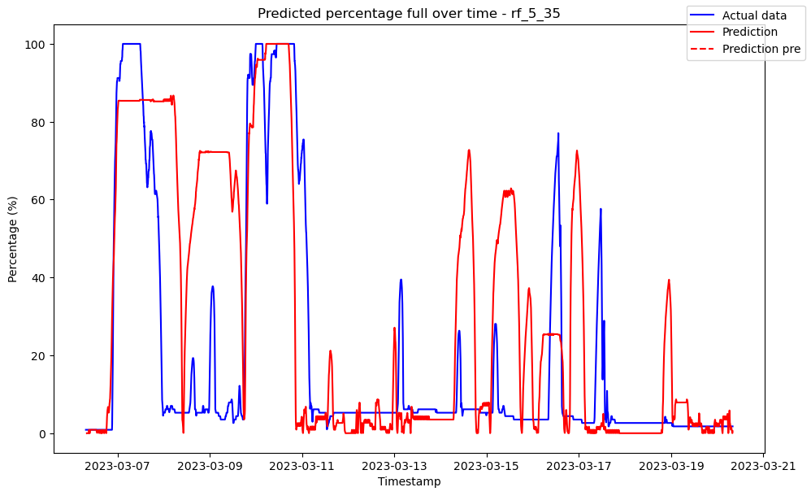

# ------------------------------------ rf_6_27 ------------------------------------

Pre-predictions:

timestamp percentage_current rainfall_current

0 2023-03-06 07:30:00 0.0 0.0

1 2023-03-06 07:35:00 0.0 0.0

2 2023-03-06 07:40:00 0.0 0.0

3 2023-03-06 07:45:00 0.0 0.0

4 2023-03-06 07:50:00 0.0 0.0

5 2023-03-06 07:55:00 0.0 0.0

Metrics for this specific prediction:

Accuracy: 99.99%

Mean squared error: 0.07654428547900688

Variance (R²) score: 1.00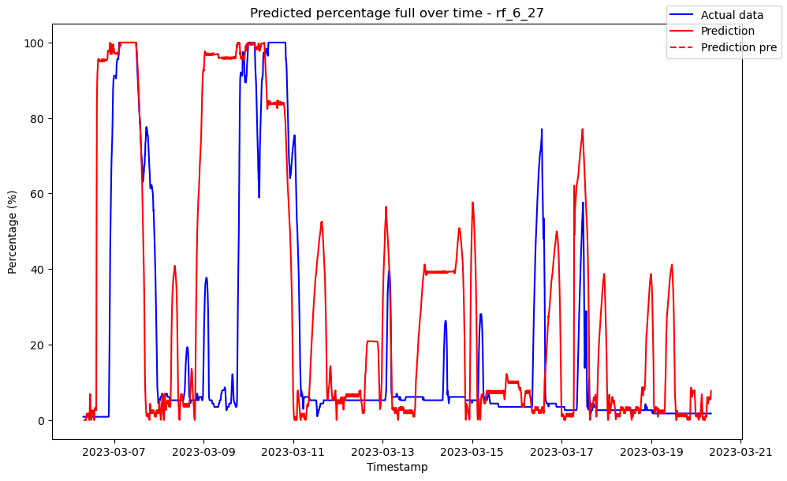

# ------------------------------------ rf_7_22 ------------------------------------

Pre-predictions:

timestamp percentage_current rainfall_current

0 2023-03-06 07:30:00 0.006464 0.0

1 2023-03-06 07:35:00 0.134190 0.0

2 2023-03-06 07:40:00 0.521391 0.0

3 2023-03-06 07:45:00 0.949102 0.0

4 2023-03-06 07:50:00 2.120286 0.0

5 2023-03-06 07:55:00 3.514286 0.0

Metrics for this specific prediction:

Accuracy: 99.99%

Mean squared error: 0.08619052153718379

Variance (R²) score: 1.00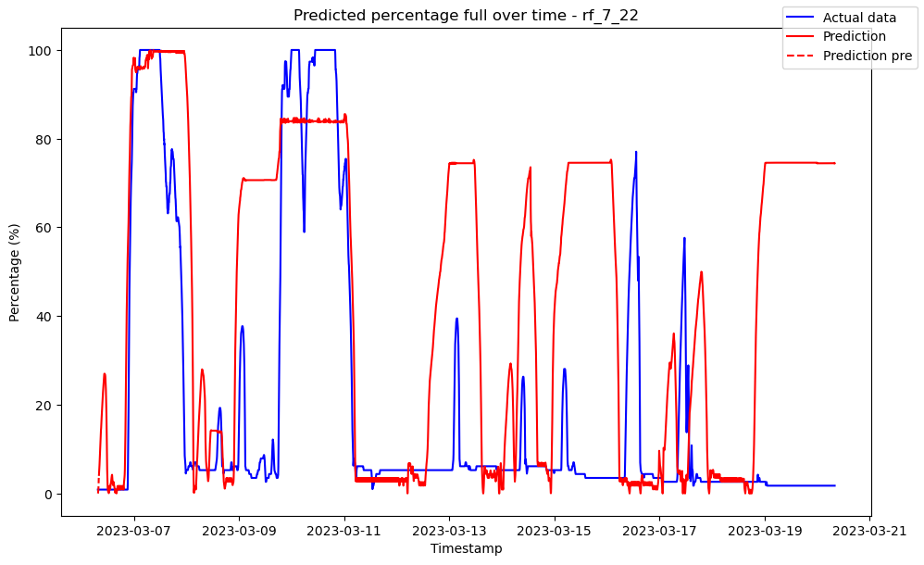

# ------------------------------------ rf_7_34 ------------------------------------

Pre-predictions:

timestamp percentage_current rainfall_current

0 2023-03-06 07:30:00 0.0 0.0

1 2023-03-06 07:35:00 0.0 0.0

2 2023-03-06 07:40:00 0.0 0.0

3 2023-03-06 07:45:00 0.0 0.0

4 2023-03-06 07:50:00 0.0 0.0

5 2023-03-06 07:55:00 0.0 0.0

Metrics for this specific prediction:

Accuracy: 99.99%

Mean squared error: 0.10310333675770979

Variance (R²) score: 1.00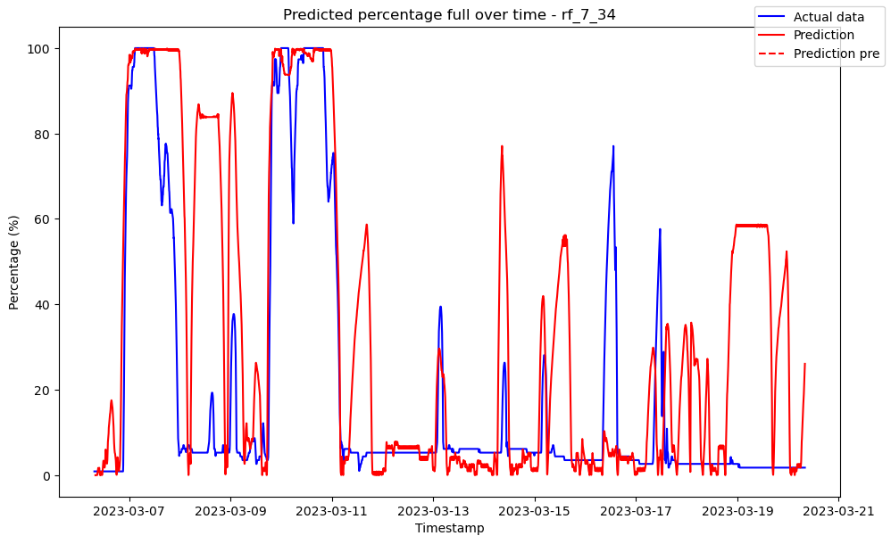

# ------------------------------------ rf_7_44 ------------------------------------

Pre-predictions:

timestamp percentage_current rainfall_current

0 2023-03-06 07:30:00 0.0 0.0

1 2023-03-06 07:35:00 0.0 0.0

2 2023-03-06 07:40:00 0.0 0.0

3 2023-03-06 07:45:00 0.0 0.0

4 2023-03-06 07:50:00 0.0 0.0

5 2023-03-06 07:55:00 0.0 0.0

Metrics for this specific prediction:

Accuracy: 99.99%

Mean squared error: 0.10038179306250616

Variance (R²) score: 1.00 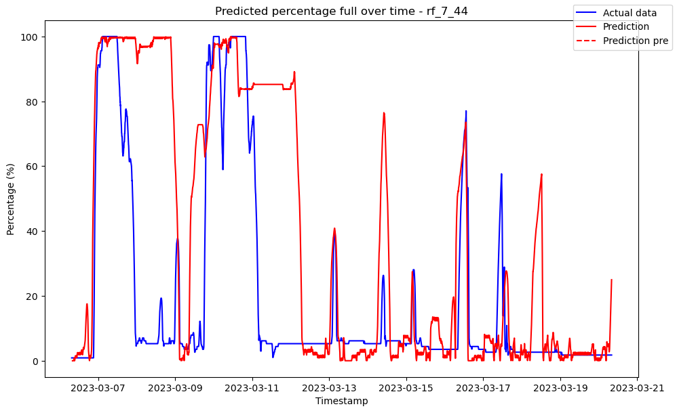

# ------------------------------------ rf_8_22 ------------------------------------

Pre-predictions:

timestamp percentage_current rainfall_current

0 2023-03-06 07:30:00 0.005656 0.0

1 2023-03-06 07:35:00 0.158666 0.0

2 2023-03-06 07:40:00 0.525937 0.0

3 2023-03-06 07:45:00 0.782625 0.0

4 2023-03-06 07:50:00 0.758364 0.0

5 2023-03-06 07:55:00 0.427217 0.0

Metrics for this specific prediction:

Accuracy: 99.99%

Mean squared error: 0.10666534672447074

Variance (R²) score: 1.00 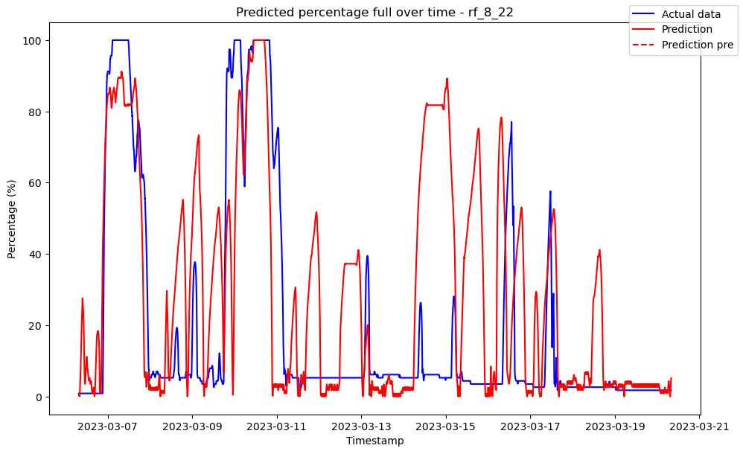

# ------------------------------------ rf_8_35 ------------------------------------

Pre-predictions:

timestamp percentage_current rainfall_current

0 2023-03-06 07:30:00 0.0 0.0

1 2023-03-06 07:35:00 0.0 0.0

2 2023-03-06 07:40:00 0.0 0.0

3 2023-03-06 07:45:00 0.0 0.0

4 2023-03-06 07:50:00 0.0 0.0

5 2023-03-06 07:55:00 0.0 0.0

Metrics for this specific prediction:

Accuracy: 99.99%

Mean squared error: 0.1281523188664712

Variance (R²) score: 1.00 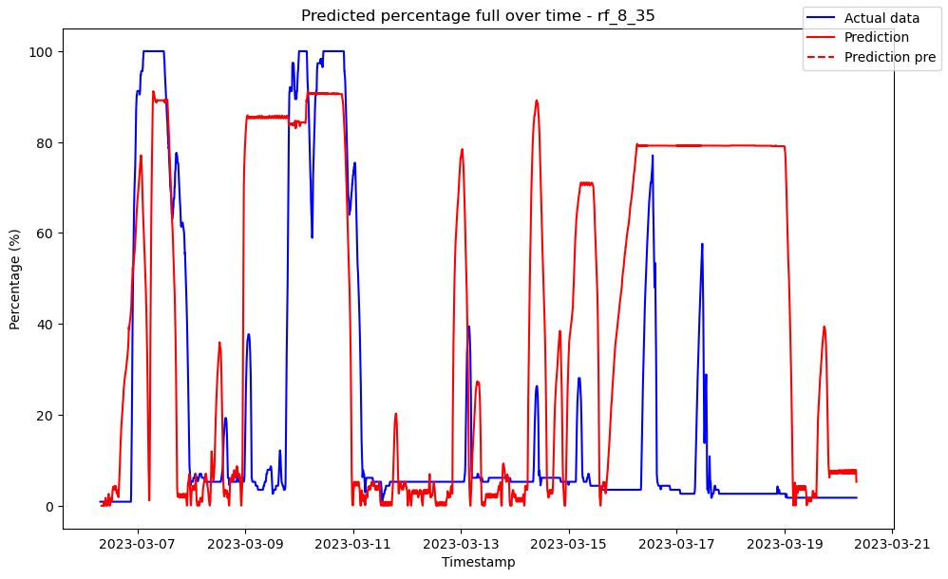

# ------------------------------------ rf_8_42 ------------------------------------

Pre-predictions:

timestamp percentage_current rainfall_current

0 2023-03-06 07:30:00 0.0 0.0

1 2023-03-06 07:35:00 0.0 0.0

2 2023-03-06 07:40:00 0.0 0.0

3 2023-03-06 07:45:00 0.0 0.0

4 2023-03-06 07:50:00 0.0 0.0

5 2023-03-06 07:55:00 0.0 0.0

Metrics for this specific prediction:

Accuracy: 99.99%

Mean squared error: 0.11440756883826753

Variance (R²) score: 1.00